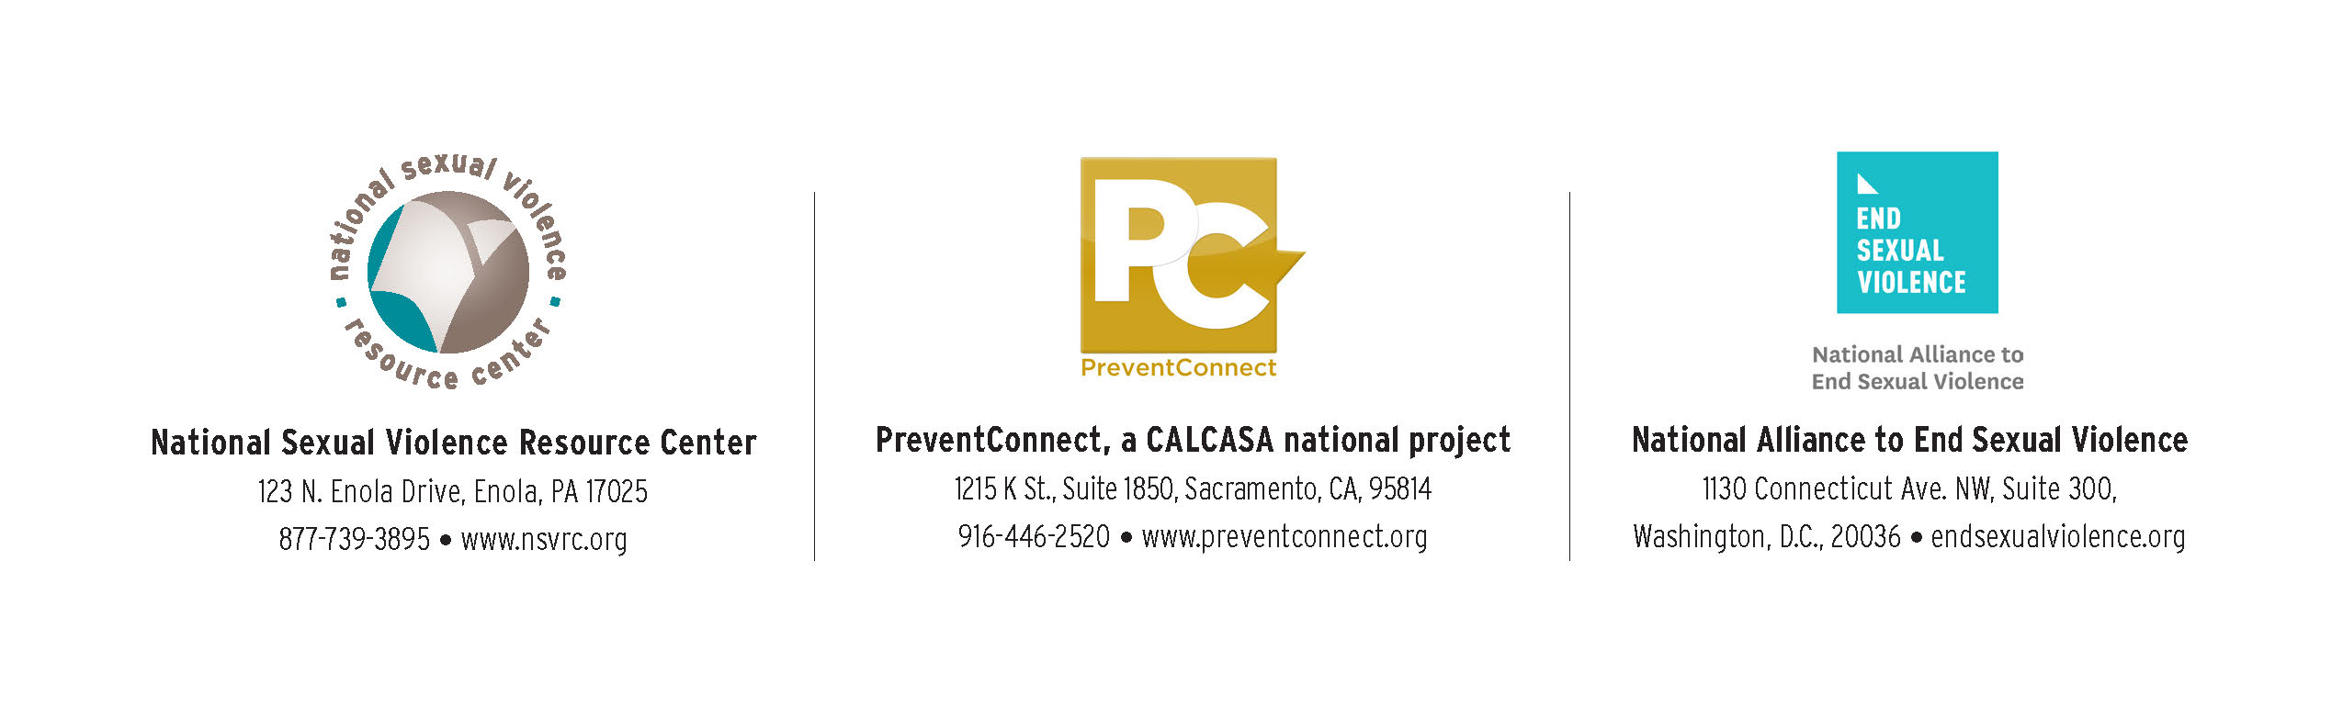

Call for Youth Summit Planning Council Applications

Deadline for Submission: June 22nd, 2016

The California Coalition Against Sexual Assault / PreventConnect, the National Alliance to End Sexual Violence, and the National Sexual Violence Resource are on a mission to end sexual violence in one generation! To help us build collective power and voice to achieve this, we are organizing a **Youth Summit in March 2017 in Washington DC.** The purpose of this event will be to engage more than 100 sophomore and junior High School students at a 3-day summit. At the Youth Summit, participants will engage in leadership and learning opportunities through three tracks:

1. Using **social media** and **messaging** to change public opinion on gender-based violence
2. Leveraging the influence of ‘**sports’** and **athletes** to end gender-based violence
3. Catalyzing individuals and communities through **community organizing** and **policy advocacy** to end

gender-based violence

**Call for Applications for the Planning Council**

We invite **established gender-based violence prevention activists and leaders** who meet the below criteria to apply to join the **2017 Youth Summit Planning Council.**

**Overview of the Youth Summit Planning Council**

The Planning Council will serve as the primary leadership and content planning body for the Youth Summit. Council members will provide their guidance and expertise to develop the vision and content of the Youth Summit as well as guide the selection process for participants of the Youth Summit. Council members will be required to complete and fully participate in the following **‘Council Member Commitments’ between July 1st 2016 and March 31st 2017**:

* Attend an in-person Council meeting in Washington DC on Thursday July 14th, 2016
* Join a video conference meeting on Thursday August 11th, 2016 (3 hrs) and subsequent bimonthly meetings via video conference (1.5 hrs)
* Attend the Youth Summit from March 13th-17th, 2016
* Contribute to or lead at least one Council subcommittee
* Complete individual research and outreach assignments
* Complete occasional reading assignments

In order to support the full participation of the Council Members, we will provide:

* A stipend of $1000 to each Council Member, upon completion of Council Member Commitments
* Expenses for travel (airfare, transportation, lodging, and food) to the Council Meeting on July 14th, 2016 and the Youth Summit from March 13th-17th 2017, both in Washington DC.

**Applicant Criteria**

* Between the ages of 18 and 25
* Must be fully available to complete the above listed Council Member Commitments
* Has at least 1 year experience in leading, participating in, or organizing gender-based violence prevention activities, particularly as it relates to any of the three conference tracks
* Currently engaged and/or connected to local gender-based prevention violence work, preferably through an established local, state, or national mission-driven organization or network
* Has experience working, living, or volunteering in diverse settings and environments
* Is self-directed, dependable, creative, and passionate about ending gender-based violence in one generation

**Nomination Requirement**

Each applicant must obtain a Nomination Letter from a non-profit, business, or established network that has an interest in gender based violence prevention and activism. The Nomination Letter must include:

* Organization/Business/Network letterhead
* Nominator signature
* Description of the connection between the application and organization/business/network
* Description of the leadership capacity of the applicant
* Description of how the nominator will support the applicant throughout the Planning Council term (July 2016 to March 2017).

**Application Process**

1. Complete the below application in it’s entirety
2. Obtain a Nomination Letter
3. Send your Application, Resume, Signed Commitment Statement, and Nomination Letter in PDF format and saved as STATEABBEVIATION_LASTNAME_FIRSTNAME (ex. AZ_SMITH_AMY.pdf) to [YouthSummit@calcasa.org](mailto:YouthSummit@calcasa.org) **by 5p PST on Wednesday June 22nd 2016.**

**Subsequent Timeline**

* By Thursday June 23rd 2016 – Select applicants will be invited for an interview
* Friday June 24th – 30 minute Interview for select applicants
* Thursday June 30th – Council Members announced

**Organization Information**

PreventConnect/The California Coalition Against Sexual Assault (PreventConnect/CALCASA), the National Sexual Violence Resource Center (NSVRC), and the National Alliance to End Sexual Violence (NAESV) have established a new partnership in order to increase visibility for, and access to, sexual violence prevention expertise. This initiative has received funding from the National Football League (NFL) to coordinate prevention, policy, and messaging efforts; establish a presence in the Washington, D.C. metro area; and to award grants to promote a variety of promising practices.

**Youth Summit Planning Council Application**

**Section I: Contact Information**

Please provide the below information to be used only during the application process and if selected as a Council Member:

Legal Name (ex. On your ID):

Preferred Name:

Gender (on ID):

Preferred Gender Identification:

Date of Birth:

Mailing Address:

City, State, Zip

Cell Phone

Email:

Twitter Handle:

Instagram Handle:

School (if applicable):

Employer (if applicable):

Emergency Contact Name:

Relationship:

Phone Number:

Email:

**Section II: Application Questions**

1. Tell us a bit about yourself! What do you want us to know about you? (150 word maximum)
2. Describe an experience where you stepped into leadership that demonstrates (150 word maximum):
   1. Your passion, commitment and creativity in working to end gender-based violence
   2. Your experience or expertise in at least one conference track (social media/messaging; community organizing/policy advocacy; sports/athletics)
3. Tell us about a time that you solved a problem and how you went about it. (150 word maximum)
4. We hope that Council Members will bring their full-selves and will provide space think ‘big’ about new and unique possibilities that the Youth Summit could provide. What is one big, bold idea that you would bring to the visioning and planning of the Youth Summit? (200 word maximum)
5. Please rank your level of interest in contributing to deeper thinking on each of the Youth Summit Tracks (1 – most interested to 3 – least interested):

______ Using **social media** and **messaging** to change public opinion and discourse on gender-based violence

______ Leveraging the influence of ‘**sports’** and **athletes** to end gender-based violence

**______** Catalyzing individuals and communities through **community organizing** and **policy advocacy** to end

gender-based violence

**Section III: Nomination Letter and Resume**

Please request and obtain a **1 page** Nomination Letter from an organization, business, or established network that has an interest in gender based violence prevention and activism. The Nomination Letter must include:

* Organization/Business/Network letterhead
* Nominator signature
* Description of the connection between the application and organization/business/network
* Description of the leadership capacity of the applicant
* Description of how the nominator will support the applicant throughout the Planning Council term (July 2016 to March 2017).

Please prepare a **1 page resume** that highlights your previous experience working, volunteering, leading, etc. activities that contributed to ending gender-based violence. Be sure to identify or describe your role and a few tasks that you completed during these activities.

**Section IV: Council Member Commitment Statement**

**I, _________________________, confirm that by completing this application, I am aware and fully committed to participate completely in each of the below listed Council Member Commitments:**

* **Attend an in-person Council meeting in Washington DC on Thursday July 14th, 2016**
* **Join a video conference meeting on Thursday August 11th, 2016 (3 hrs) and subsequent bimonthly meetings via video conference (1.5 hrs)**
* **Attend the Youth Summit from March 13th-17th, 2016**
* **Contribute to or lead at least one Council subcommittee**
* **Complete individual research and outreach assignments during the 9 month planning timeline**
* **Complete occasional reading assignments**

**Signature: __________________________________________ Date: _______________________**

**Section V: Submission Instructions**

Send your Application, signed Council Member Commitment Statement, Resume, and Nomination Letter in PDF format and saved as STATEABBEVIATION_LASTNAME_FIRSTNAME (ex. AZ_SMITH_AMY.pdf) to [YouthSummit@calcasa.org](mailto:YouthSummit@calcasa.org) **by 5pm PST Wednesday June 22nd 2016.**